MEMT 201
HW #14 – Ceramics/Concrete

A Portland cement concrete cylinder that is 6 inches in diameter and 12 inches tall is tested in compression test. The deformations shown were measured with a device over the middle 8 inches of the cylinders height. Requirements on next page.

Load  (lbs) | Deformation  (in)
0 | 0
25,000 | 0.001
46,000 | 0.002
65,000 | 0.003
78,000 | 0.004
90,000 | 0.005
101,000 | 0.006
107,000 | 0.007
108,500 | 0.008
110,000 | 0.009
111,000 | 0.01
111,500 | 0.011
110,500 | 0.012

Required:

A. Plot the stress vs. engineering strain for the cylinder.

Using the equation for cross-sectional area:

π/4 * (6 in)² = 28.27 in²

Then using σ = Load / Area to find the Stress at each reading
Load (lbs) | Deformation (in) | Stress (lb/in²)
0 | 0 | 0
25,000 | 0.001 | 884.1941283
46,000 | 0.002 | 1626.917196
65,000 | 0.003 | 2298.904734
78,000 | 0.004 | 2758.68568
90,000 | 0.005 | 3183.098862
101,000 | 0.006 | 3572.144278
107,000 | 0.007 | 3784.350869
108,500 | 0.008 | 3837.402517
110,000 | 0.009 | 3890.454164
111,000 | 0.01 | 3925.82193
111,500 | 0.011 | 3943.505812
110,500 | 0.012 | 3908.138047
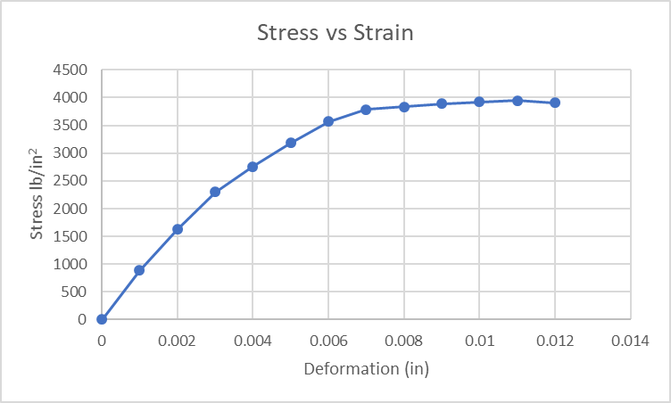
B. Determine the ultimate compressive strength.
According to the chart, this is 3908.14 lb/in².

C. Determine the modulus of elasticity, E. by three different methods.
Initial tangent
ΔStress = 884.19 lb/in²
ΔStrain = 0.001

ΔStress/ ΔStrain = 884.19/0.001 = 884190 lb/in²

Tangent at the working stress
Working stress = 3908.14 lb/in² * 2 / 3 = 2605.43 lb/in²

ΔStress = 459.78 lb/in²
ΔStrain = 0.001

ΔStress / ΔStrain = 459780 lb/in²

Secant at the working stress

ΔStress = 2605.43 lb/in²
ΔStrain = 0.0036

ΔStress / ΔStrain = 723730.56 lb/in²

Assume that the working stress is 2/3rd of the ultimate strength.

